**A Project Report**

*On*

**“Credit Management System”**

*Submitted By*

**Kanani Jenish (206230307037)**

**Devang Sharma (206230307054)**

**Krish Lathia (206230307180)**

*In partial fulfillment of requirements for the degree*

*Of*

**DIPLOMA ENGINEERING**

*In*

*Computer Engineering*



**Government Polytechnic, Gandhinagar**

**Gujarat Technological University, Ahmedabad**

December - 2022

**CERTIFICATE**



**Government Polytechnic, Gandhinagar**

Computer Engineering

2022-2023

This is to certify that the project work embodied in this report entitled “**Credit Management System**” was carried out by **Mr. Kanani Jenish, Mr. Devang Sharma & Mr. Krish Lathia at Government Polytechnic, Gandhinagar** for partial fulfillment of the Diploma degree to be awarded by Gujarat Technological University (GTU). This project work has been carried out under my supervision and is to the satisfaction of the department.

**Place:** GP, Gandhinagar

**Date:**

**Internal Guide Head of the Department**

**Prof. S. B. Prasad** Prof. Manish Desai

**Acknowledgement**

I sincerely feel the credit of the project work could not be narrowed down to only on individual. The development of this project involves many valuable contributions. Getting the opportunity for this project of “**Credit Management System**” as fulfillment of diploma (computer engineering) has been brightening experience for the near future to come and a focus on excellence in this venture, we are constantly guided and encouraged by **Prof. S. B. Prasad** who is our internal guide.

I would also thank our Head of the Department **Prof. Manish Desai** for giving us such a wonderful chance to work with this interesting project and perform the project work for the entire duration of the semester and thanks to internal guide for project technical guidance and giving inspiration in all the way during project making. Finally, I would like to thank our parents, friends and almighty for being with us to support directly or indirectly while making this project.

**Abstract**

“Credit Management System” is a desktop-based application which is going to be useful for managing the details about

‘Credit’ given to Individuals/Small Business Owners by the Cooperation Geoid Vistech Private Limited.

Main task of this application is going to be the management of the Database automatically where the details about credit given to people has been managed till now manually on Excel File.

The application is not just going to manage the database but will also contain features like applying interest on credit and creating timelines (Date of the EMI) of the installment, alerting the company officials “When” and “How” much amount of Credit/Money is to be taken from “Whom” through a message inside the application and on through the Email.

**Table of Contents**

|  |  |  |
| --- | --- | --- |
|  | Acknowledgement |  |
|  | Abstract |  |
|  |  |  |
| Chapter 1 | Introduction………………………………………………….... |  |
|  | 1.1 Problem Summary…………………………………………   * 1. Project Purpose……………………………………………   2. Project Scope………………………………………………   1.4 Project Objective…………………………………………. | 8  8  8  8 |
| Chapter 2 | System specification………………………………………….. |  |
|  | * 1. Hardware Requirement……………………………………. | 9 |
|  | * 1. Software Requirement…………………………………….. | 9 |
|  | * 1. Requirements Analysis…………………………………….   2. Constraints…………………………………………………   3. Assumptions and Dependencies……………………………   4. Technology and Literature Review………………………… | 9  11  11  12 |
| Chapter 3 | System diagrams………………………………………………. |  |
|  | * 1. Use case Diagram…………………………………………   2. ER Diagram………………………………………………..   3. Data Flow Diagram………………………………………….   4. Sequence Diagram…………………………………………..   5. Activity Diagram……………………………………………   6. Data Dictionary…………………………………………….. | 0  0  0  0  0  0 |
| Chapter 4 | Implementation & Planning |  |
|  | 4.1 Implementation Environment………………………………  4.2 Snap Shots………………………………………………….. | 0  0 |
| Chapter 5 | Conclusion…………………………………………………….. | 0 |
| Chapter 6 | Future works…………………………………………………… | 0 |
| Chapter 7 | Bibliography & reference……………………………………… | 0 |
|  | 7.1 Books…………………………………………………….  7.2 Websites…………………………………………………… | 0  0 |

**Chapter 1: Introduction**

**1.1 Problem Summary:**

Geoid Vistech Pvt. Ltd. gives credit with decided interest on it to Individuals/Small Business owners, but the company must manage all information like Credit Amount, Detail about the Credit taker, when installments will be paid back.

But the company must manage all this work manually in Excel Sheets which is very hard to keep up with.

* 1. **Project Purpose:**

This application’s main purpose is to take the whole work online and automate the work through programming.

* 1. **Project Scope:**

To help many “Credit” lenders like Geoid Vistech in managing the data on Excel Sheets, create an installment timeline (Date of the Installments).

* 1. **Objective:**

The objective of this application is to go with a computerized system that manages the details about money lent by Credit Lender, and to help owners need not to worry about the installment reminders.

**Chapter 2: System specification**

* 1. **Hardware Requirement:**

**Minimum Hardware:**

* RAM: 2 GB
* CPU: Intel i3 (Gen 7)
* Storage: Around (400 MB)

**Recommended Hardware:**

* RAM: 8 GB
* CPU: Intel i3 (Gen 9 or above)
* Storage: 1 GB
  1. **Software Requirement**

**User site:**

* Windows 10 or above
* Excel 2021

**Developer’s site:**

* VS code
* Excel
  1. **Requirements Analysis**
* It is a written document that contains detailed information about the requirement to run the Credit Management System [CMS].
* **There are two types of requirements:**
* Functional Requirement
* Non-Functional Requirement
* **Functional Requirement:**

**R1: Loanee Registration:**

**Input:** User must Fill out Form with Loanee’s Detail Like:

(First Name, Last Name, Mobile Number, Address, Aadhaar Card Number, Pan Card Number, Bank Account Number).

**Output:** Registration Successful, Unique ID number created for Loanee which will be sent to Loanee via Mail.

**R2: Loan Creation:**

**Input:** Amount of loan with decided Interest, Time-Period on it.

**Output:** Successful Loan Creation & Loan ID Generated.

**R3: Loan Type:**

**Input:** Type of Loan, remarks.

**Output:** Remarks Added.

**R4: Loan Details:**

**Input:** Enter Unique ID Number or Name Detail.

**Output:** All Details Related to Loanee and all his ongoing & previous loans are displayed.

* **Non-Functional Requirement**

1. **Usability:**

CMS is going to be very simple and easy application. Anyone just using it once will be enough for them to be friendly with the interface.

1. **Performance:**

Performance will depend on the device that is going to run the application and lack of or low memory in system will affect the performance of it.

1. **Maintainability:**

To update or troubleshoot this application, an IT expert is needed to reach the target place to fix the problem.

1. **Security:**

Since there is going to be only 1 User, fewer are the chances of Data Theft or Server Crashes.

* 1. **Constraints**
* Constraints that are there in CMS are:

1. The constraint this application has that it is only Single User Application.
2. When any installment is near the Loanee will be reminded about it through emails and through Mobile SMS.
   1. **Assumptions and Dependencies**

This application is going to be used by the Credit Lenders only but whenever someone’s installment date is near, this application is going to give them a reminder through email with details of their installments.

* 1. **Technology and Literature Review**

Technologies going to be used in our application are:

**1) HTML 5:**

* HTML stands for Hyper Text Markup Language​.
* It is a standard markup language used for creating basic structure of Websites, applications, etc.​
* It is used to describe the structure of a Web page.
* Elements of HTML tell the browser how to display the Content.​

**2) CSS:​**

* CSS stands for Cascading Style Sheets.​
* It describes how a document written in HTML is to be displayed on screen, paper, or in other form of media.​
* It saves a lot of work. It can control the layout of multiple web pages all at once.​
* Using CSS one can make look a web document more attractive than a simple HTML Web document.

**3) Python:**

* Python is High-level, General Purpose Programming Language.
* Being one of the easiest languages out there, Python lets us program quickly and integrate systems quickly.
* It consists of a syntax that lets us code with fewer lines comparatively than others.
* It was designed for readability and has similarities to English which makes it even easier to understand.

**4) Excel:**

* Microsoft Excel is a spreadsheet developed by Microsoft for Windows, macOS, Android and iOS.
* It features calculation or computation capabilities, graphing tools, pivot tables, and a macro programming language called Visual Basic for Applications. Excel forms part of the Microsoft Office suite of software.

**Chapter 3: System diagrams**

* 1. **Use case Diagram:**

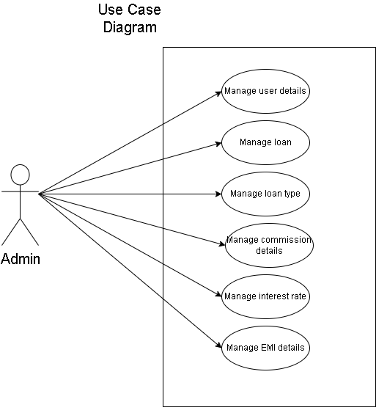

* 1. **ER Diagram:** 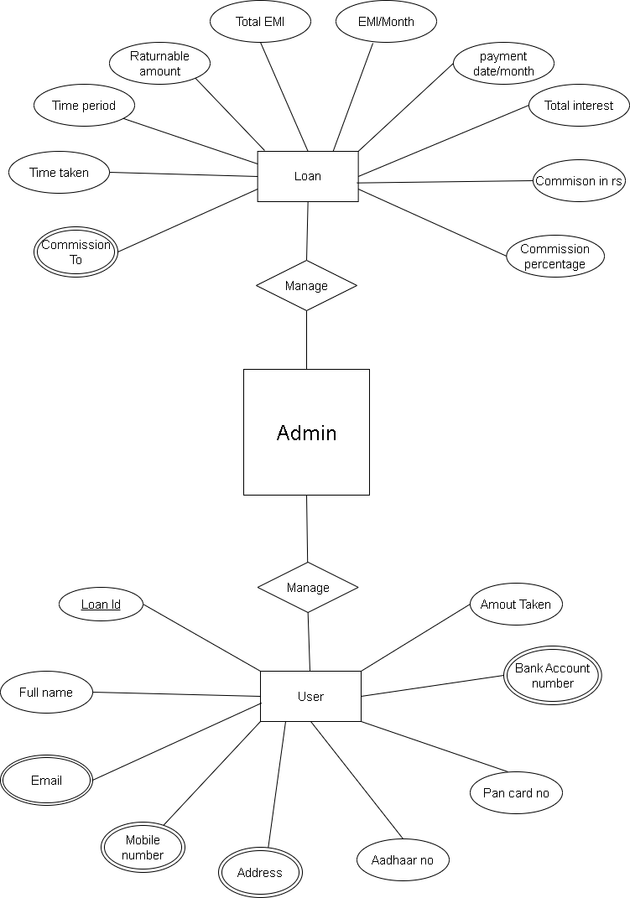
  2. **Sequence Diagram:**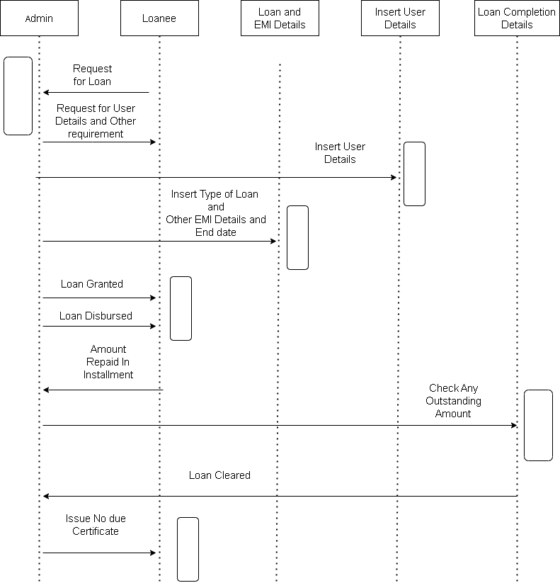
  3. **Activity Diagram:**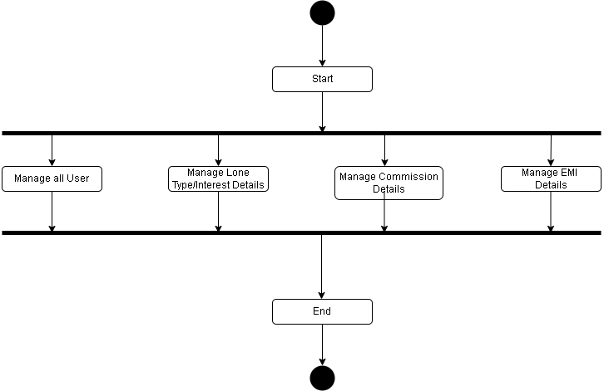

**Chapter 4: Implementation & Planning**

* 1. **Implementation Environment:**

Google Chrome, Media platforms, and YouTube are our implementing environment studies. We will conduct the case studies and multiple examples referencing our application

**Chapter 5: Conclusion**

* Finally, in the Credit Management System, the outcome of all the hard work done for the Loan management system is here. This software reduces the amount of manual data entry and gives greater efficiency. The design is very simple so anyone can use it. It also decreases the amount of time taken to write customer details and other modules.

**Chapter 6: Future works**

* In a natively digital age, digital technologies are taking over businesses and industries globally, and the traditional lending business as we know it is becoming obsolete. This is just the beginning. As time passes by, more & more customers will be using this application so almost every single customer interaction will be handled by virtual assistants. We will add some extra feature in future as (Voice message, Direct message, etc.). For fast lending process we will work on faster lending process.

**Chapter 7: Bibliography & Reference**

* 1. **Websites:**

**Main Website that is used for the reference by Us:**

* [**https://www.youtube.com/watch?v=gfDE2a7MKjA&t=40783s**](https://www.youtube.com/watch?v=gfDE2a7MKjA&t=40783s)
* [**https://www.youtube.com/watch?v=7YS6YDQKFh0&t=159s**](https://www.youtube.com/watch?v=7YS6YDQKFh0&t=159s)
* [**https://wiki.python.org/moin/BeginnersGuide**](https://wiki.python.org/moin/BeginnersGuide)